St Ives Town Council | 

46th John Knill Celebrations Saturday 25th July 2026

Date: April 2026

The John Knill Ceremony is held every 5 years and was first held in 1801. This year it will take place on Saturday 25th July 2026. The local community have helped to preserve this old St Ives ceremony for over 200 years and so the Knill Trustees (The Mayor, Customs Officer and the Vicar) look forward to welcoming nominations for this years event.

The invitation to take part is extended to:

- Girls aged 10 years of age or under and local to St. Ives. The daughters of Seamen, Fishermen or Tinners will be given priority, but others are eligible. The chosen girls will dance and sing around the Knill Monument.
- Widows of Seamen, Fishermen or Tinners of the Town, being 64 years old or upwards (if possible), who will attend the dancing and singing of the girls.

In accordance with the Will of John Knill, it is customary for a token payment to be made to participants.

Anyone interested in taking part is asked to apply to the Town Council, by completing the form attached, setting out how they meet the above criteria.

The form can also be found here and is available to collect from The Guildhall or Cornerstone Library

Please complete online

or return via email enquiries@stives-tc.gov.uk

or by post: The Town Clerk, St. Ives Town Council, The Guildhall, St. Ives, TR26 2DS.

All nominations must be received by 23rd May 2026. The Knill Trustees will then consider nominations, and lots will be drawn.



L Dwelly
Town Clerk

enquiries@stives-tc.gov.uk
01736 797840 (Option 8)

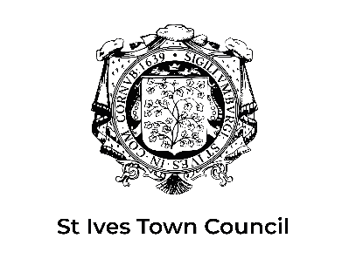
John Knill Celebration 2026

Event: 46th John Knill Celebrations
Date of Event: Saturday 25 July 2026
Application Deadline: 23 May 2026

Section 1: Applicant Category (please tick)
☐ Girl aged 10 years or under
☐ Widow
(Please complete all sections relevant to the category selected.)

Section 2: Applicant Details
Full Name:
Date of Birth:
Age (On 25th July 2026):
Current Address:
Postcode:
Telephone Number:
Email Address:

Section 3a: Applications for Girls (if applicable)
School attended (if applicable):

Please indicate whether the applicant is the daughter of:
☐ Seaman ☐ Fisherman ☐ Tinner ☐ Other (Please Specify)
Please include any relevant family details

Section 3b: Applications for Widows (if applicable)
Please indicate if the applicant is a widow of:
☐ Seaman ☐ Fisherman ☐ Tinner ☐ Other (Please Specify)
Please include any relevant family details

Section 4: Consent and Declarations

For Parent / Guardian (for child applicants)
I confirm that the information provided is accurate to the best of my knowledge and that I consent to the applicant taking part in the John Knill Celebration should they be selected.

Parent or Guardians Name:
Relationship to applicant:
Signature:
Date:

For Widow Applicants
I confirm that the information provided is accurate to the best of my knowledge and that I am willing to take part in the John Knill Celebration should I be selected.

Signature:
Date:

Section 5: Additional Information (optional)
Please provide any additional information you feel the Trustees should consider; this may include family connections to previous celebrations.

Submission Details
Completed applications should be submitted by 23 May 2026:

- By email: enquiries@stives-tc.gov.uk
- By post:
St Ives Town Council
The Guildhall
St Ives
TR26 2DS

Data will be used solely for the purpose of administering the John Knill Celebration 2026 and handled in accordance with applicable data protection legislation.

